Competitive Shooters of Lake Norman USPSA February 13th, 2026
COURSE DESIGNER: Rocky Perillo

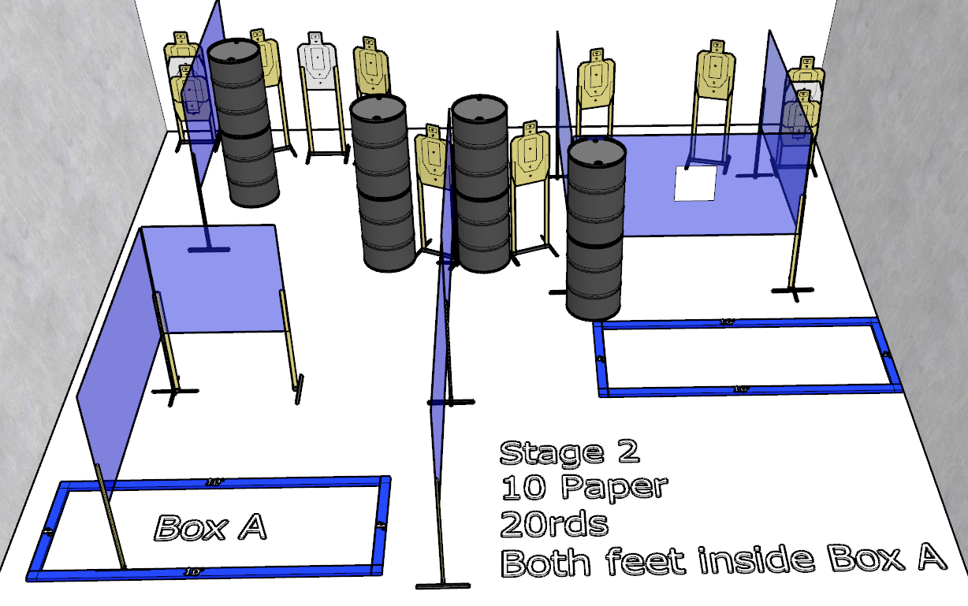

Stage 2 – If it bleeds, we can kill it.
20 rounds, 100 points, Comstock
There are 10 cardboard targets with some no-shoots.
Starting with both feet inside Box A.
Handgun is unloaded and holstered. Wrists below belt.
PCC is unloaded held in both hands stock touching belt.
On the audible start signal, engage targets from within the shooting area.

